**ConResult: OBE Result Management System**

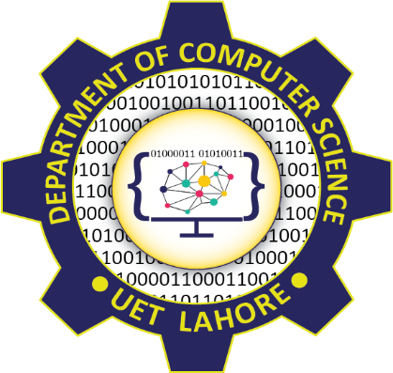

Session: 2021 – 2025

**Submitted by:**

Afraz Butt , 2021-CS-12

**Supervised by:**

Mr. Nouman Babar

Mr. Samyan Qayyum Wahla

Department of Computer Science

**University of Engineering and Technology**

**Lahore, Pakistan**